**Simple Android Application that makes use of Database**

Aim:

        To develop a Simple Android Application that makes use of Database.

Procedure:

Creating a New project:

* Open Android Studio and then click on **File -> New -> New project.**

[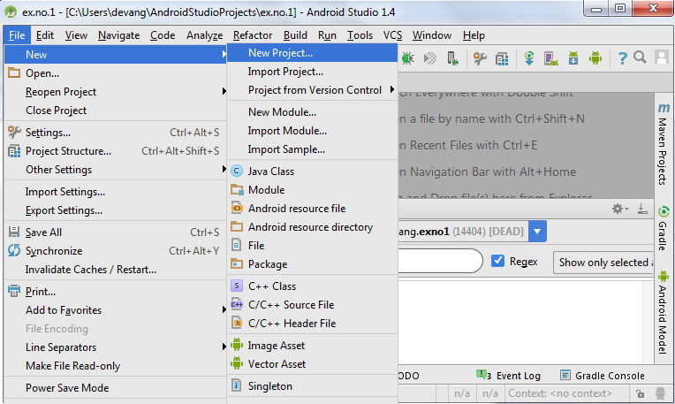](https://codingconnect.net/wp-content/uploads/2016/02/new-project.png)

* Then type the Application name as “**expno4″** and click **Next.**
* Then select the **Minimum SDK** as shown below and click **Next**.
* Then select the **Empty Activity**and click **Next.**
* Finally click F**inish**.
* It will take some time to build and load the project.
* After completion it will look as given below.

Designing layout for the Android Application:

* Click on **app -> res -> layout -> activity_main.xml.**
* Now click on **Text** as shown below.
* Then delete the code which is there and type the code as given below.

Experiment 4-

**MainActivity.java**

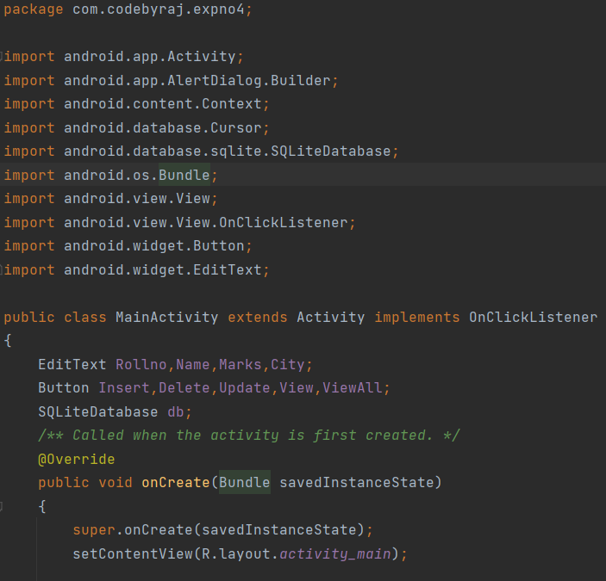

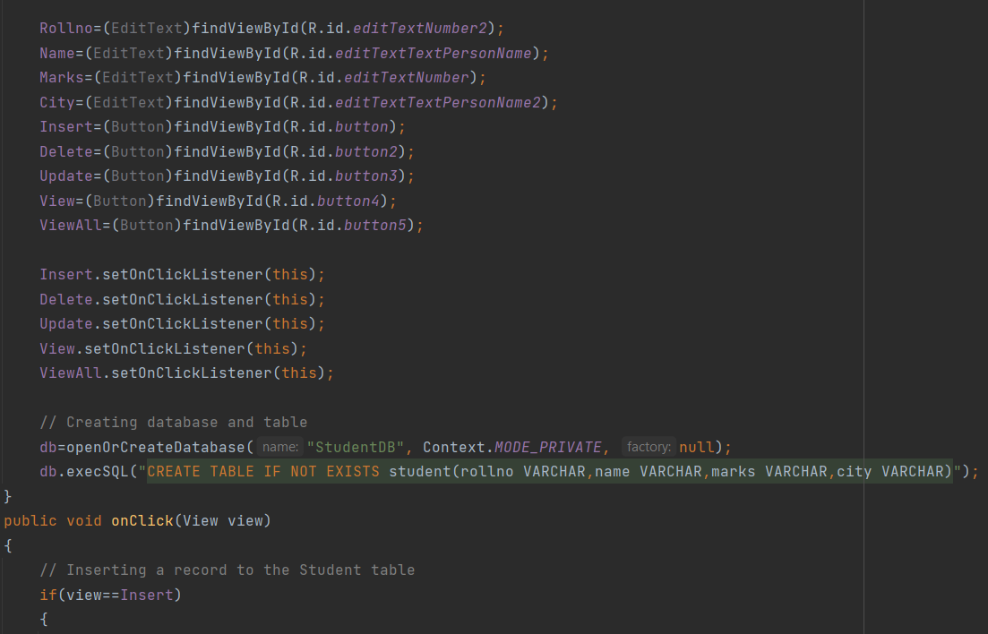

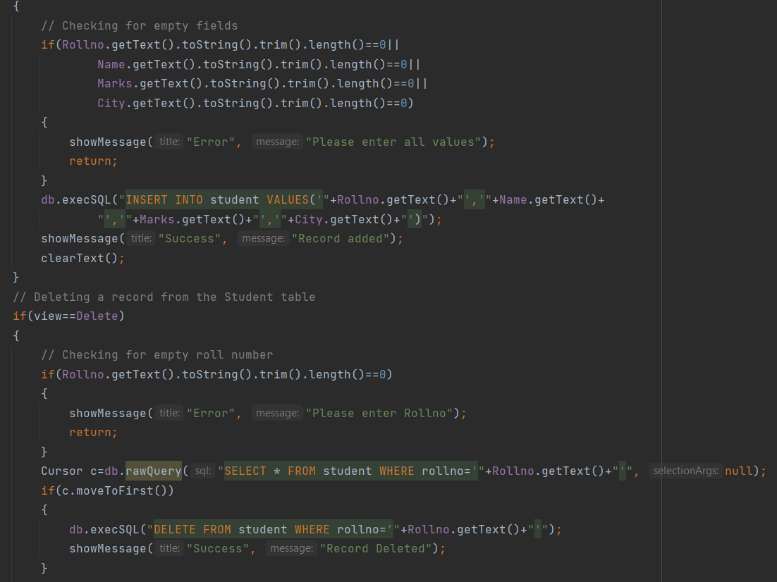

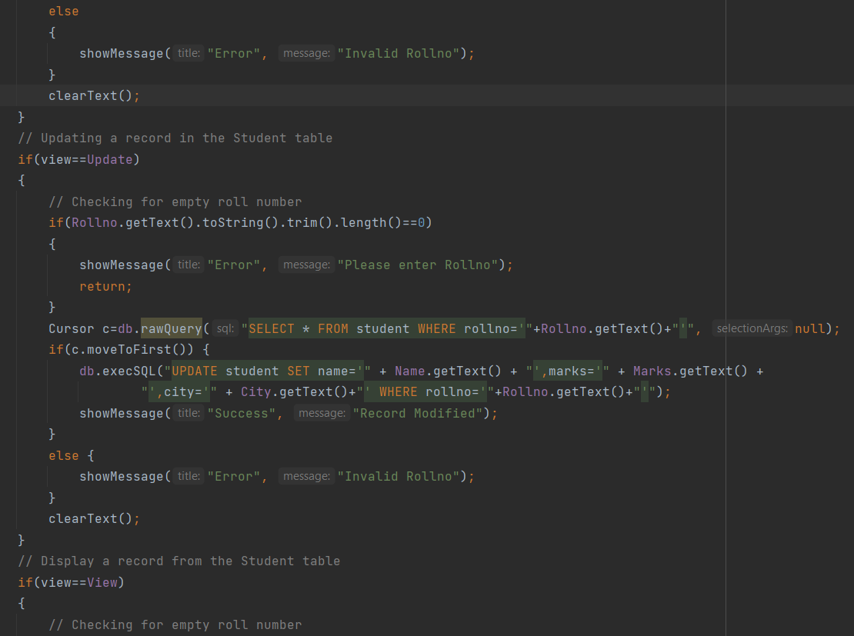

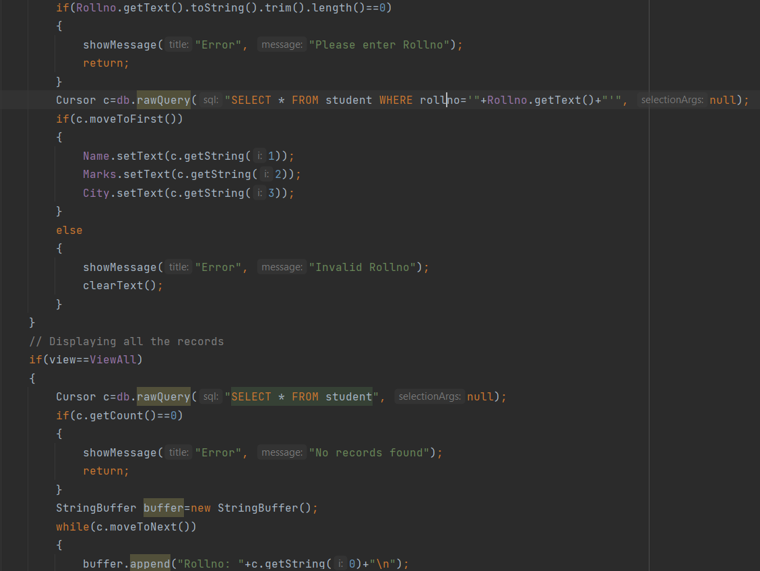

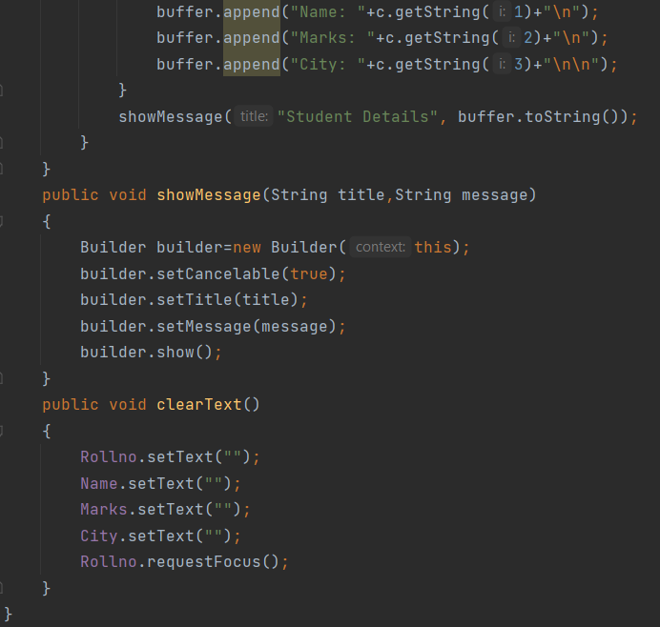

**activity_main.xml**

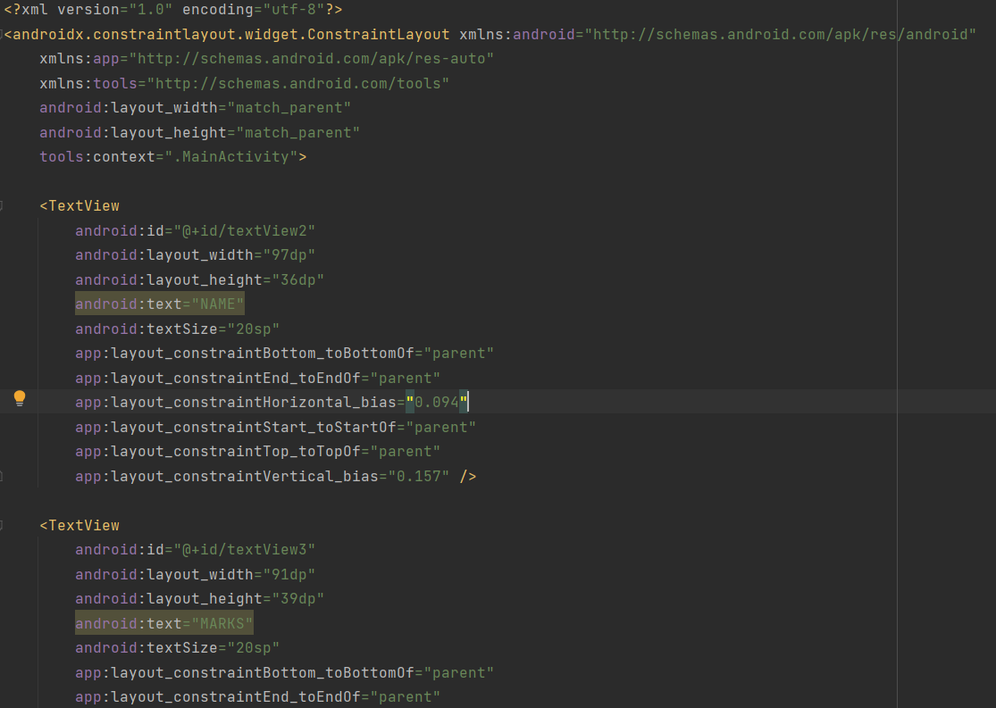

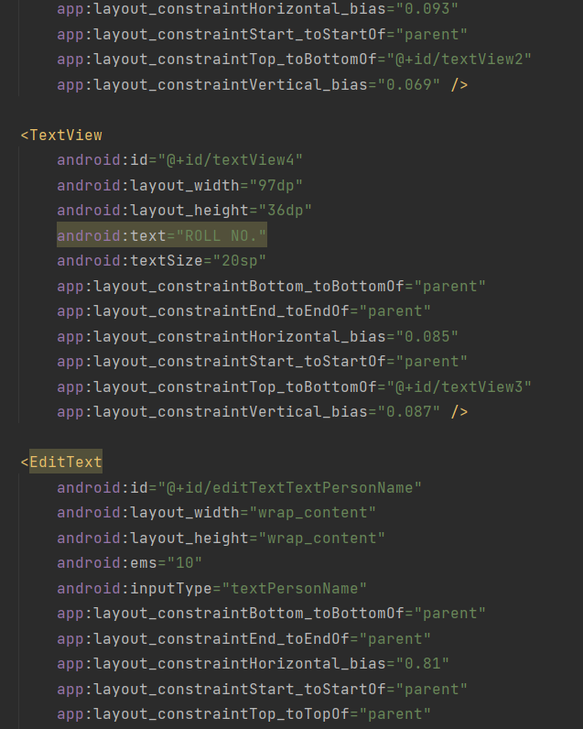

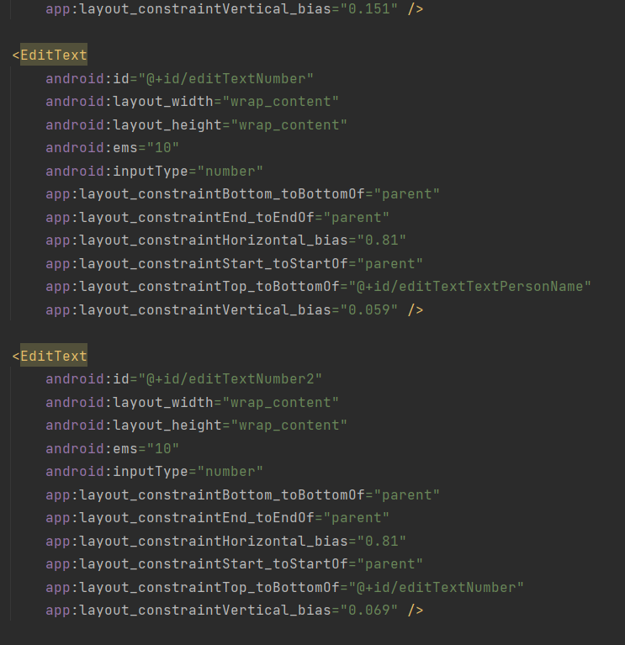

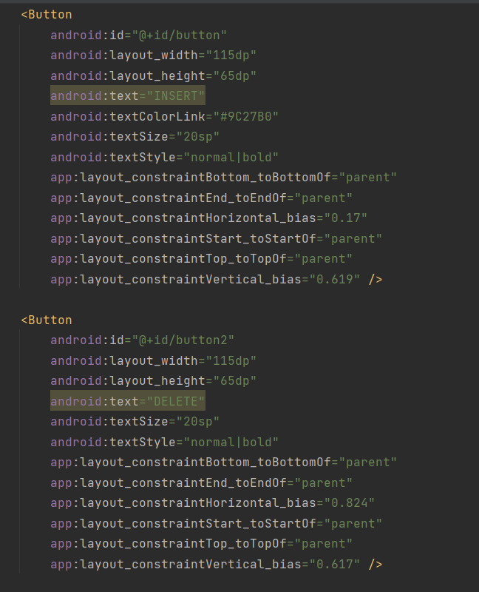

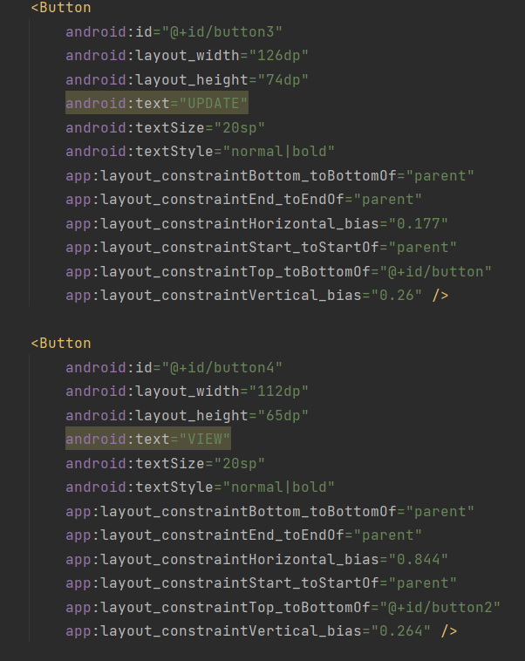

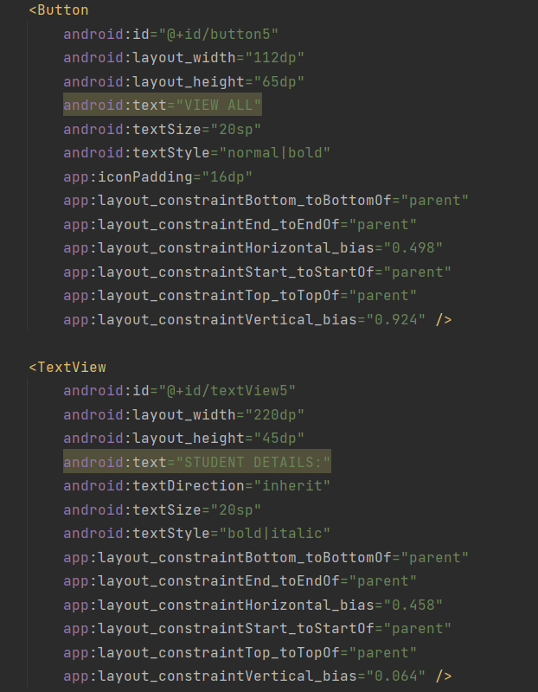

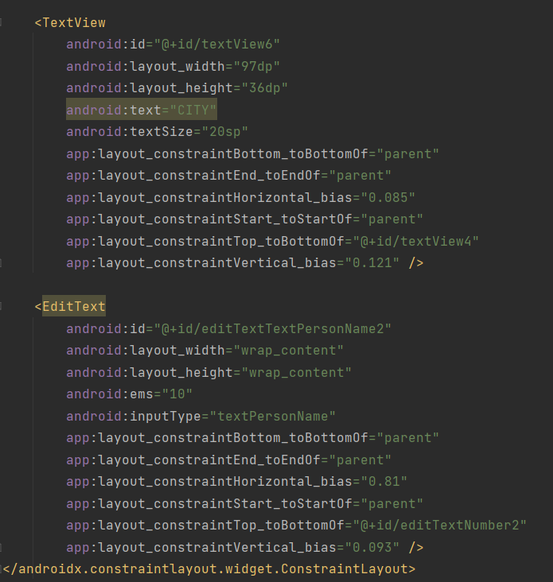

**Output-**